

Essence of Music
Initial Project and Group Identification Document

Group 36 (might be incorrect, forgot group number)
Baron Dolletski-Lazar (CpE)
Joshua Garber (EE)
Nelson Tan (CpE)

Motivation:
Everyone enjoys listening to music and we are no exception to this. Often time people are listening to music while being productive (or for enjoyment), and we would like to add to that audio experience with a visual aspect in order to create a more calm and relaxing environment. That being said, today’s society has an obsession with wireless technologies and ease-of-use; one important motivation for our project is that we want practice sending and receiving data wirelessly through Wi-Fi. From a design perspective, this will challenge and teach us how to apply filters to music signals while also helping us realize how to apply devices such as 802.11 Wi-Fi capability in order for ease-of-use for the device’s user. Music is something that our group is passionate about and adding a visual component sounds both enjoyable and compelling to create.

Goals and Objectives:
Our goals are to gain experience with popular wireless technology whether it be Bluetooth, 802.11, or some other commonplace medium. Another important goal is to learn how to use and program microcontrollers/microprocessors such as Arduino or Raspberry in a practical environment. We want to create a portable device that analyze audio messages and convert them into something visually enjoyable.

Project Requirements:
- 802.11 compatibility (Bluetooth as potential alternative)
- Under 3 sq. ft. in size
- Under 5 pounds
- An array of multicolored LED lights. Minimum of 16x16
- Maximum power usage of 50 Watts
- An Arduino microcontroller (Raspberry Pie as alternative)
- Functions between 0-80 Celsius
- Runs on a single rechargeable battery
- One charge lasts at least 2 hours
- Must have adjustable color settings (for moods such as cool or warm colors)
- Smartphone or Web app that lets phones send their currently playing audio to the device (Ideally using Wi-Fi or Bluetooth) as well as control settings for the device
- 10 yard range if Bluetooth
Key Block Diagrams:
Top Level Block Diagram
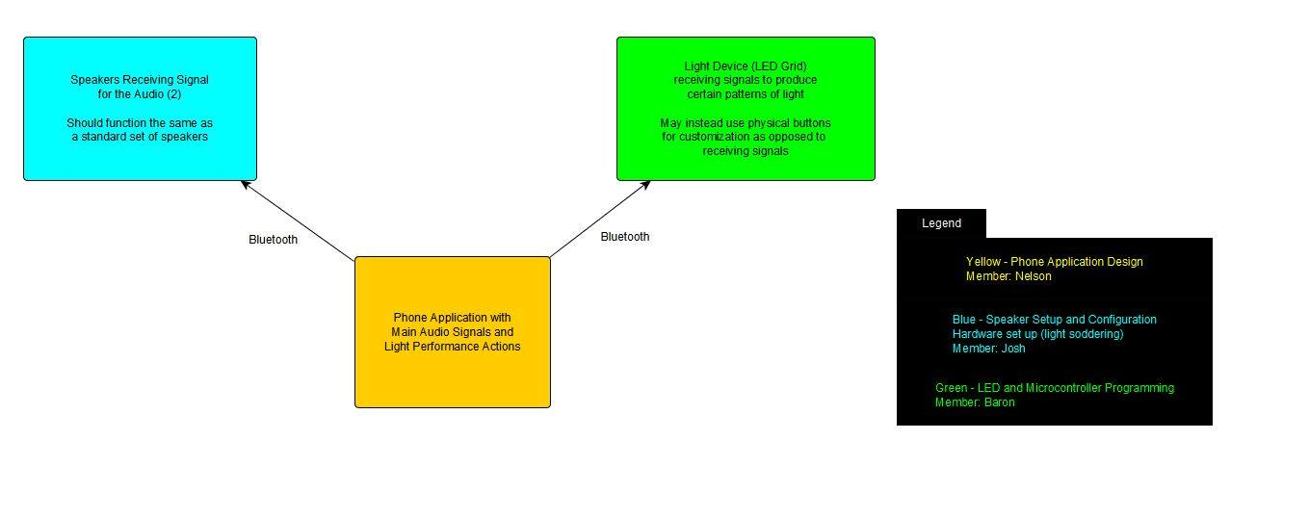
Hardware Block Diagram
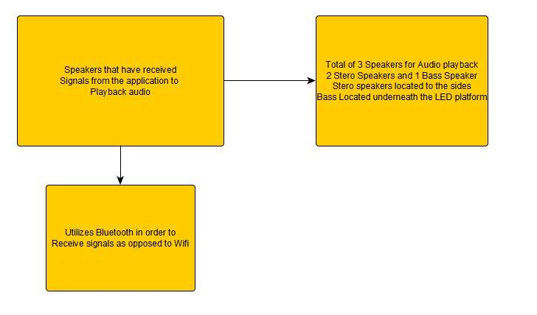

Microcontroller Block Diagram
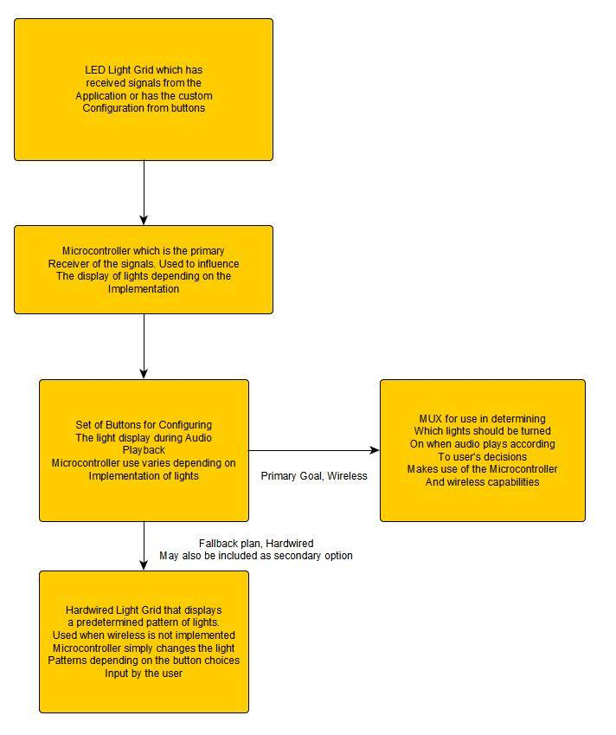
Budget and Financing:

Item | Price | Quantity | Overall Price
Raspberry Pi (Option 1) | $50 | 1 | $50
Arduino Microcontroller (Option 2) | $60 | 1 | $60
LEDs | $5 per 50 | 256 | ~$25
Wires | $5 | 50 ft. spool | $5
Rechargeable Battery Pack | $20 | 1 | $20
Speakers | $20 | 2 | $40
Bass Speaker | $20 | 1 | $20
MUX | $15 per 10 | 20 | $30
Bluetooth Receiver Board (Option 1) | $20 | 1 | $20
WiFly Module (Option 2) | $50 | 1 | $50
Breadboard | $5 | 1 | $5

Total Estimate $325

Milestones:
Senior Design One
- Definition
  - Initial Project Documents
- Research
  - Perform Research into Arduino and Raspberry Pi
  - Figuring how to use 802.11 and A2DP protocols
  - Create a master list of helpful sites
  - Research equipment necessary for testing
- Design
  - Complete overall design of Project
  - Determine final Development tasking
  - Obtain and utilize graphing software
  - Complete final design documentation
- Obtain all needed supplies
  - Start testing
Senior Design Two
- Prototype
  - Fully program phone software
  - Fully program microcontroller
  - Build the hard machine
  - Integrate all systems
- Test
  - Test all individual systems
  - Test all systems within integration
  - Final Comparison to project requirements
  - If time permits, extra add ons

Decision Matrices:
